|  |  |  |  |  |  |  |
| --- | --- | --- | --- | --- | --- | --- |
| **Sl.NO** | **Risk** | **Likelihood** | **Impact** | **Severity** | **Existing Controls** | **Mitigation Strategies** |
| **1**. | Unauthorized access to user data. | High | High | High | Basic authentication mechanisms | Implement strong authentication mechanisms such as multi-factor authentication(MFA)prevent unauthorized access. |
| **2**. | Inadequate backup and disaster recovery mechanism | Low | High | Medium | Basic backup mechanisms | Implement comprehensive backup disaster recovery mechanisms to ensure data availability and system continuity. |
| **3**. | Lack of encryption for data in transit or at rest. | Medium | Medium | Medium | No encryption mechanisms | Implement encryption mechanisms such as SSL/TLS for data in transit and encryption algorithms for data at rest. |
| **4.** | Malware or virus attacks compromising system integrity. | Medium | High | High | Basic anti malware mechanism | Deploy anti malware and intrusion detection/prevention systems to detect and prevent malware attacks. |
| **5.** | Data loss due to technical failures or system errors | Medium | High | High | Regular data backups, redundancy measures | Implement comprehensive data backup and recovery mechanisms redundant storage systems, and regular system monitoring. |
| **6.** | Poor user experience usability issues | Low | Medium | Low | User feedback, usability testing | Conduct user feedback collection and usability testing to improve user experience and address usability issues. |
| **7.** | Lack of user education and awareness | Medium | Low | Low | User training programs | Provide regular user education and awareness programs on topics such as eBook usage, data privacy, and security best practices**.** |

**Project Risk Assessment**

**EBook-Management System**

**REQUIREMENT SPECIFICATION**

Functional

• Register - Enter details in application form.

• Login - Enter Username and Password.

• Search - Search book by attribute.

• Payment - Pay for books .

• Update - Update User details

• Categories - Book categories like New ,Old Book.

2.4.2 Non-functional

• Performance

• Scalability

• Security

• Usability

• Maintenance and Support

• Accessibility

**Class Diagram**

The class diagram depicts a static view of an application. It represents the types of objects residing in the system and the relationships between them. A class consists of its objects, and also it may inherit from other classes. A class diagram is used to visualize, describe, document various different aspects of the system, and also construct executable software code.

It shows the attributes, classes, functions, and relationships to give an overview of the software system. It constitutes class names, attributes, and functions in a separate compartment that helps in software development. Since it is a collection of classes, interfaces, associations, collaborations, and constraints, it is termed as a structural diagram.

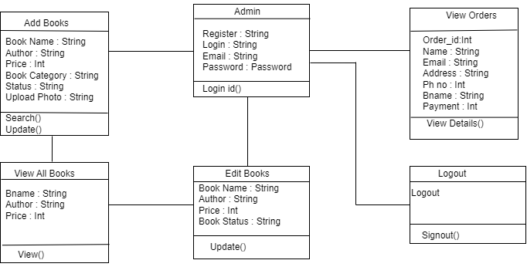

Fig 2.8.1 Admin Class Diagram

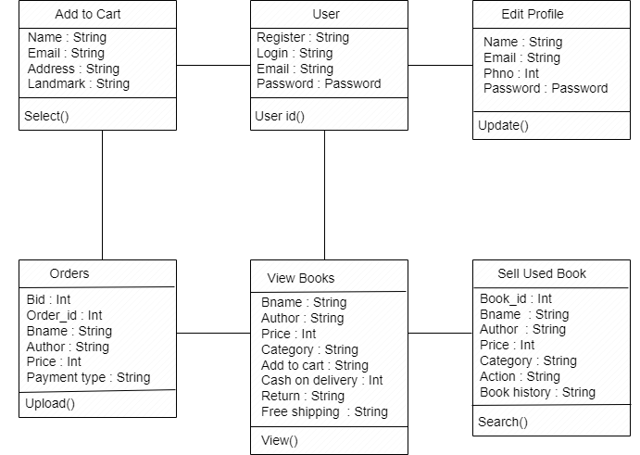

Fig 2.8.2 User Class Diagram

**SEQUENCE DIAGRAM**

Sequence diagram and collaboration diagram or called INTERACTION DIAGRAMS. An interaction diagram shows an interaction, consisting of set of objects and their relationship including the messages that may be dispatched among them.

A sequence diagram is an introduction that empathizes the time ordering of messages, graphically a sequence diagram is a table that shows objects arranged

Along the X-axis and messages ordered in increasing time along the Y-axis.

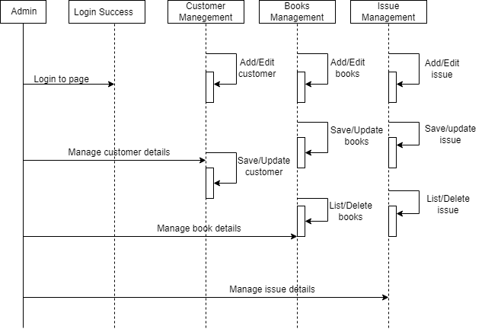

Fig 2.9.1 Admin Sequence Diagram

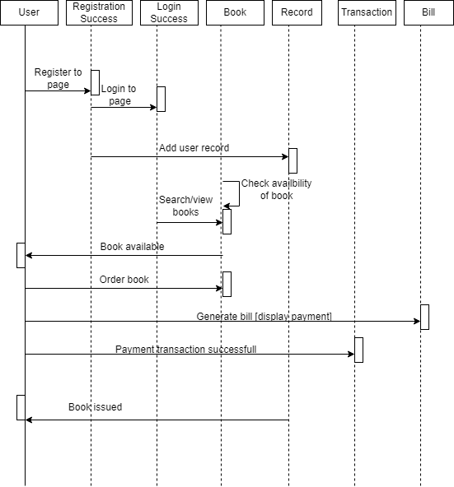

Fig 2.9.2 User Sequence Diagram

**2.10 USE-CASE DIAGRAM**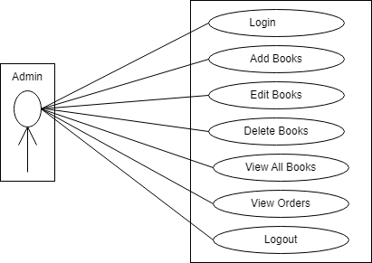

Fig 2.10.1 Admin Use Case Diagram

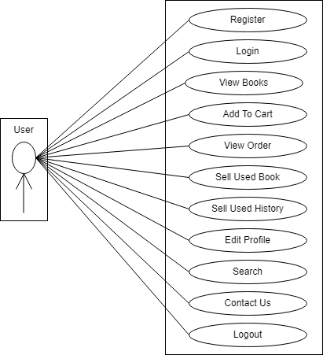

Fig 2.10.2 User Use Case Diagram

**Test Cases**

|  |  |  |  |  |  |  |
| --- | --- | --- | --- | --- | --- | --- |
| SL No | Test Id | Test Description | Steps to Execute | Input Data | Expected Output | Result |
| 01 | User_01 | **User registration** Check user registration page properly displayed with all tags. | a).Start MySQL workbench database and Apache -tomcat 9.0 server is on.  b).Browser localhost:8080/Ebook-App/register.jsp | Not applicable | The related registration page is displayed. | Pass |
| 02 | User_02 | Check for successful user registration. | a).Enter user full name, email address, phone no, password.  b). Click on submit button | Enter all the user details has been correct. | User registration successfully and move on to the login page. | Pass |
| 03 | User_03 | Check for unsuccessful user registration. | a).The user is already exist.  b).If user not check agree terms & condition. | Not applicable | a).Appear User Already Exist Try Another Email id. b).Error message will appear Please check agree terms & condition.Top of Form | Pass |
| 04 | User_04 | Check for user registration for the user. | a).The user can be empty user id and password click on submit button. | Not applicable | The user registration can be successful. | Pass |
| 05 | User_05 | **User login** Check user login page properly display with email id and password. | a).Start MySQL workbench database and Apache-tomcat 9.0 server is on.  b).Browser localhost:8080/Ebook-App/login.jsp. | Not applicable | The related login page is displayed. | Pass |
| 06 | User_06 | Check for successful login | a).Enter email id and password.  b). Click on login button | Valid email id & password. | The user login can be successful. | Pass |
| 07 | User_07 | Check for unsuccessful login | a).Enter incorrect email id and password.  b). Click on login button. | Invalid email id & password. | Error message will appear email & password invalid. | Pass |
| 08 | User_08 | **View Books**  In the view menu check books are properly displayed or not. | a).Click on View details button. | Not applicable | a).If book is new click on add to cart.  b).If book is old contact through email. | Pass |
| 10 | User_10 | **Add Cart**  Click on add cart button. | a).Applied only for new book | Not applicable | Successful message will appear (Book added to cart ). | Pass |
| 11 | User_11 | Successful order click on cart button. | a).Enter name, email, phone no, address, landmark, city, state, pin code, payment mode.  b).Click on Order Now button. | Enter all the details has been correct. | Successful message will display. | Pass |
| 12 | User_12 | Unsuccessful order | a).If payment mode is not selected. | Not applicable | Error message will appear(Choose payment mode). | Pass |
| 13 | User_13 | **View Orders**  Check successful view orders. | a).With user login they can view orders.  b).Click on view button. | Not applicable | a).Successfully users view the orders.  b).User view Book details. | Pass |
| 14 | User_14 | Check unsuccessful view orders. | a).Without user login they can’t view orders. | Not applicable | The login page will displayed. | Pass |
| 15 | User_15 | **Sell used book**  Check for successful sell used book. | a).With user login they can sell the used books.  b).Click on sell button. | Enter the all book details. | a).Successfully users sell the used books.  b)Successful message will appear(book added successfully). | Pass |
| 16 | User_16 | Check for unsuccessful sell used book. | a).Without user login they can’t sell the used books. | Not applicable | The login page will displayed. | Pass |
| 17 | User_17 | **View sell used book history**  Check for successful view sell used book history. | a).With user login they can view sell used book history.  b).Click on delete button. | Not applicable | a).Successfully users view the used book history.  b).Successful message will appear(Old book deleted successfully). | Pass |
| 18 | User_18 | Check for unsuccessful view sell used book history. | a).Successfully users view the orders. | Not applicable | The login page will displayed. | Pass |
| 19 | User_19 | **Edit profile**  Check for successful edit profile. | a).Enter email id and name that you want to update.  b). Click on update button | Valid email id & password. | The user edit profile can be successful. | Pass |
| 20 | User_20 | Check for unsuccessful edit profile. | a).Enter incorrect email id and password.  b). Click on update button. | Invalid email id & password | Error message will appear email & password invalid. | Pass |
| 21 | User_21 | **Search**  Check for successful search books. | a).Enter book name or category or author.  b).Click on search button. | Not applicable | Successfully users can search the books. | Pass |
| 22 | User_22 | **Contact us**  User can have contact us option. | a).Enter Name, Email, Subject, Message.  b).Click on send button. | Enter required details. | Successful message will appear. | Pass |
| 23 | User_23 | **Logout**  User can have logout option. | User can click on logout button. | Control go to user home page. | Display message for logout (Logout successfully). | Pass |

|  |  |  |  |  |  |  |
| --- | --- | --- | --- | --- | --- | --- |
| SL No | Test Id | Test Description | Steps to Execute | Input Data | Expected Output | Result |
| 01 | Admin_01 | **Admin login**  Click admin login page properly display with email id, password | a).Start MySQL workbench database and Apache tomcat 9.0 server is on. | Not applicable | The related login page is displayed. | Pass |
| 02 | Admin_02 | Check for successful login | a).Enter email id and password.  b).Click on login button. | Valid login email id and password | a)Login successful.  b)move on the admin page is displayed. | Pass |
| 03 | Admin_03 | Check for unsuccessful login for empty admin login email id and password | a).Empty email id and password.  b).Click on login button. | Not applicable | Display administration area page. | Pass |
| 04 | Admin_04 | **Add books**  Check for successful add books | a).Enter bookname, author name, price, book categories, book status, upload photo.  b).Click on add button. | Enter all the book details has been correct | Book added successfully. | Pass |
| 05 | Admin_05 | Check for unsuccessful add books | a).Empty bookname, author name, price, book categories, book status, upload photo.  b).Click on add button. | Not applicable | Book added unsuccessfully. | Pass |
| 06 | Admin_06 | **Edit books**  Check for successful edit books | a).Enter book name, author name, price, book status.  b).Click on update. | Admin can edit the book details. | Book edit successfully. | Pass |
| 07 | Admin_07 | Check for unsuccessful edit books | a).Empty book name, author name, price, book status.  b).Click on update. | Not applicable | Book edit unsuccessfully. | Pass |
| 08 | Admin_08 | **Delete books**  Check for successful delete the books | Click on delete button. | Not applicable | Book delete successfully. | Pass |
| 09 | Admin_09 | **View all books**  Check for successfully 0  books are added | a).Click on all books button. | Admin can add the books and he can see the added books | Successfully view the added books. | Pass |
| 10 | Admin_10 | Check for unsuccessfully books are added | a).Click on all books button. | Not applicable | Unsuccessfully view the added books. | Pass |
| 11 | Admin_11 | **View Orders**  Check successfully view the user orders | a).Click on order button.  b).admin can see the user orders. | Not applicable | Successfully view the orders. | Pass |
| 12 | Admin_12 | Check unsuccessfully view the user orders | a).Without admin login can’t see the user orders. | Not applicable | Login page will displayed. | Pass |
| 13 | Admin_13 | **Logout**  Admin can have a logout button | a).Admin can click on the logout button . | Control go to admin home page | Display message for u have successful logout. | Pass |